**Learners Academy**

* This document contains sections for:
* Sprint planning and Task completion
* Frameworks & technology used
* Core concepts used in project
* Flow of the portal.
* Unique Selling Points of the Application

The project is developed by **Danish Ismail Khan.**

The code for this project is hosted at

## Sprints planning and Task completion

* The project is planned to be completed in 2 sprint. Tasks assumed to be completed in the sprint are:
* Creating the flow of the application
* Initializing git repository to track changes as development progresses.
* Writing the Java code to fulfill the requirements of the project along with Servlet & JSP.
* Pushing code to GitHub.
* Creating this specification document highlighting application capabilities, appearance, and user interactions.

## Framework and Technology used

* Maven, JEE,Java 1.7, JSP, JSTL, Mysql, HTML, CSS, GIT, GITHUB, XML

## Core concepts used in project

* Array, Sorting, Flow Control, Exception Handling, Loops.

## Flow of the portal.

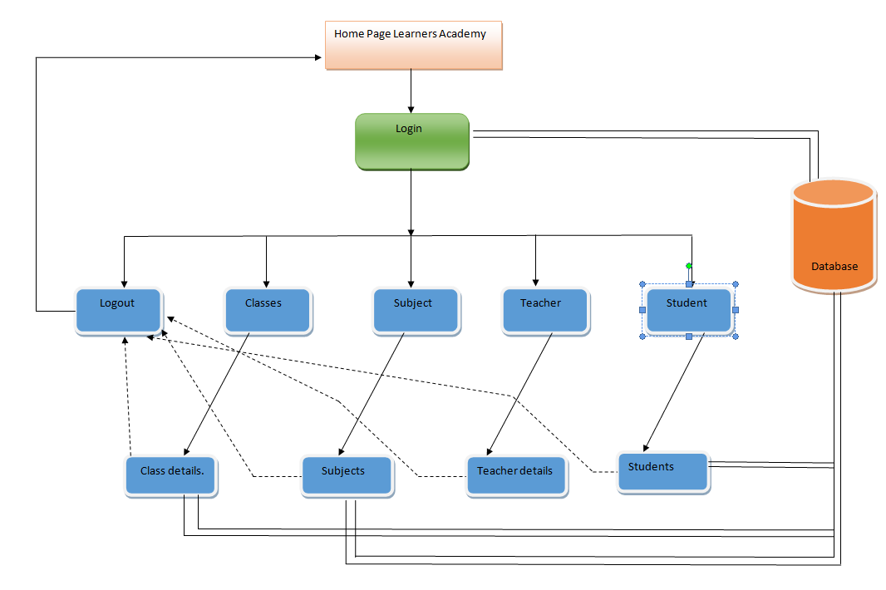

## Pushing the code to GitHub repository

1. Open your command prompt and navigate to the folder where you have created your files.
   1. **cd <folder path>**
2. Initialize repository using the following command:
   1. **git init**
3. Add all the files to your git repository using the following command:
   1. **git add .**
4. Commit the changes using the following command:
   1. **git commit . -m <commit message>**
5. Push the files to the folder you initially created using the following command:
6. **git push -u origin master**

## Unique Selling Points of the Application

1. This is an online management system of a school. It keeps a track of all the classes, subjects, students, and teachers. Management can be done with a single administrator login.
2. The user is able to seamlessly switch between WebPages.